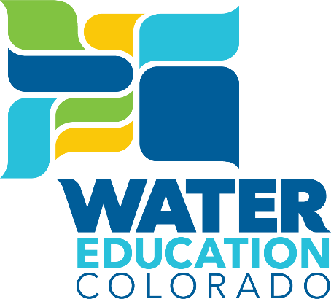

**Water Resources and Agriculture Review Committee**

**Agenda**

**March 20, 2024**

**7:30-8:45am**

**Colorado State Capitol Room HCR0112**

*This educational session will offer a continuation of the* *Demystifying Colorado Water for Legislators “Level 201” trainings begun in 2023.*

*In the first half of the session, we will cover the basics about what constitutes a wetland, the history of decisions and guidance around WOTUS' scope, culminating with the* Sackett v. EPA *decision and where that currently leaves us with regard to who has authority. We’ll also hear about the CDPHE analysis on what other states are doing and options identified for moving forward.*

*In the second half of the session, we will cover the connections between growth, land use planning and density with water demand reductions and planning. This will include an introduction to how communities forecast water demands, the impact various policies being considered could have on this, and the tools available to water providers to reduce demand.*

**7:15am Coffee and Breakfast Snacks Available for Legislators**

**7:30am Call to Order and Welcome**

*Representative Karen McCormick*

**7:35am** **Introduction to WEco and CWC and Program Overview**

*Jayla Poppleton, Executive Director, Water Education Colorado*

*Doug Kemper, Executive Director, Colorado Water Congress*

**7:40am****Wetlands, WOTUS, and Colorado’s Role**

*Gabe Racz, Partner, Vranesh and Raisch, and Colorado Water Congress Water Quality Representative*

*Nicole Rowan, Director, Colorado Water Quality Control Division*

**8:10am Growth, Density, and Water Demand Planning**

*Doug Kemper, Executive Director, Colorado Water Congress*

*Dave Payne, Assistant General Manager, Ute Water Conservancy District*

*Greg Fischer, Manager of Demand Planning, Denver Water*

**8:40am Wrap-Up and More Resources**

*Jayla Poppleton, Executive Director, Water Education Colorado*

**8:45am Adjourn**

*Representative Karen McCormick*